**GoF Design Pattern Types**

GoF Design Patterns are divided into three categories:

1. **Creational**: The design patterns that deal with the creation of an object.
2. **Structural**: The design patterns in this category deals with the class structure such as Inheritance and Composition.
3. **Behavioral**: This type of design patterns provide solution for the better interaction between objects, how to provide lose coupling, and flexibility to extend easily in future.

**Creational:** Factory Method, Abstract Factory, Singleton, Prototype, Builder, and Object Pool pattern.

**Structural**: Adapter Pattern, Bridge Pattern,Composite Pattern,Decorator Pattern,Facade Pattern,Flyweight Pattern,Proxy Pattern.

**Behavioral**: Template Method,Mediator,Chain of Responsibility,Observer,Strategy,Command,State,Visitor,Interpreter,Iterator,Memento

**ADAPTOR**

Adapter pattern works as a bridge between two incompatible interfaces. This type of design pattern comes under structural pattern as this pattern combines the capability of two independent interfaces.

This pattern involves a single class which is responsible to join functionalities of independent or incompatible interfaces. A real life example could be a case of card reader which acts as an adapter between memory card and a laptop. You plugin the memory card into card reader and card reader into the laptop so that memory card can be read via laptop.

We are demonstrating use of Adapter pattern via following example in which an audio player device can play mp3 files only and wants to use an advanced audio player capable of playing vlc and mp4 files.

**Implementation**

We have a *MediaPlayer*  interface and a concrete class *AudioPlayer* implementing the *MediaPlayer*  interface. *AudioPlayer*  can play mp3 format audio files by default.

We are having another interface *AdvancedMediaPlayer* and concrete classes implementing the *AdvancedMediaPlayer*  interface. These classes can play vlc and mp4 format files.

We want to make *AudioPlayer* to play other formats as well. To attain this, we have created an adapter class *MediaAdapter* which implements the *MediaPlayer* interface and uses *AdvancedMediaPlayer* objects to play the required format.

*AudioPlayer* uses the adapter class *MediaAdapter*  passing it the desired audio type without knowing the actual class which can play the desired format. *AdapterPatternDemo*, our demo class will use *AudioPlayer* class to play various formats.

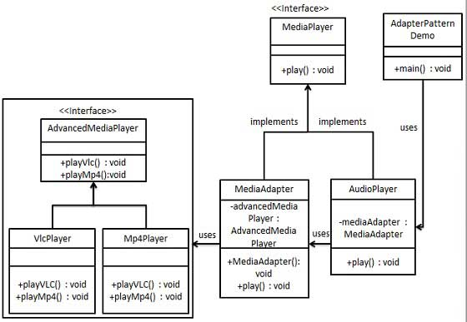

Step 1

Create interfaces for Media Player and Advanced Media Player.

*MediaPlayer.java*

public interface MediaPlayer {

public void play(String audioType, String fileName);

}

*AdvancedMediaPlayer.java*

public interface AdvancedMediaPlayer {

public void playVlc(String fileName);

public void playMp4(String fileName);

}

Step 2

Create concrete classes implementing the *AdvancedMediaPlayer* interface.

*VlcPlayer.java*

public class VlcPlayer implements AdvancedMediaPlayer{

@Override

public void playVlc(String fileName) {

System.out.println("Playing vlc file. Name: "+ fileName);

}

@Override

public void playMp4(String fileName) {

//do nothing

}

}

*Mp4Player.java*

public class Mp4Player implements AdvancedMediaPlayer{

@Override

public void playVlc(String fileName) {

//do nothing

}

@Override

public void playMp4(String fileName) {

System.out.println("Playing mp4 file. Name: "+ fileName);

}

}

Step 3

Create adapter class implementing the *MediaPlayer* interface.

*MediaAdapter.java*

public class MediaAdapter implements MediaPlayer {

AdvancedMediaPlayer advancedMusicPlayer;

public MediaAdapter(String audioType){

if(audioType.equalsIgnoreCase("vlc") ){

advancedMusicPlayer = new VlcPlayer();

}else if (audioType.equalsIgnoreCase("mp4")){

advancedMusicPlayer = new Mp4Player();

}

}

@Override

public void play(String audioType, String fileName) {

if(audioType.equalsIgnoreCase("vlc")){

advancedMusicPlayer.playVlc(fileName);

}

else if(audioType.equalsIgnoreCase("mp4")){

advancedMusicPlayer.playMp4(fileName);

}

}

}

Step 4

Create concrete class implementing the *MediaPlayer* interface.

*AudioPlayer.java*

public class AudioPlayer implements MediaPlayer {

MediaAdapter mediaAdapter;

@Override

public void play(String audioType, String fileName) {

//inbuilt support to play mp3 music files

if(audioType.equalsIgnoreCase("mp3")){

System.out.println("Playing mp3 file. Name: " + fileName);

}

//mediaAdapter is providing support to play other file formats

else if(audioType.equalsIgnoreCase("vlc") || audioType.equalsIgnoreCase("mp4")){

mediaAdapter = new MediaAdapter(audioType);

mediaAdapter.play(audioType, fileName);

}

else{

System.out.println("Invalid media. " + audioType + " format not supported");

}

}

}

Step 5

Use the AudioPlayer to play different types of audio formats.

*AdapterPatternDemo.java*

public class AdapterPatternDemo {

public static void main(String[] args) {

AudioPlayer audioPlayer = new AudioPlayer();

audioPlayer.play("mp3", "beyond the horizon.mp3");

audioPlayer.play("mp4", "alone.mp4");

audioPlayer.play("vlc", "far far away.vlc");

audioPlayer.play("avi", "mind me.avi");

}

}

Step 6

Verify the output.

Playing mp3 file. Name: beyond the horizon.mp3

Playing mp4 file. Name: alone.mp4

Playing vlc file. Name: far far away.vlc

Invalid media. avi format not supported