Group Discussion: Useful Phrases (examples)

Stating your own opinion

- In my opinion, …
- Personally I think that ...
- My own view of the matter/issue is that ...
- It seems to me that ...

Agreeing with an opinion

- Yes, I agree (absolutely).
- I couldn't agree more to what you just said.
- That matches exactly my own view.
- Yes, that is just how I see it.
- I absolutely hold the same view.
- We both share the same point of view.

Partly agreeing with an opinion

- I see what you mean, but ...
- There is certainly some truth in your words, but you fail to notice that ...
- I don't entirely agree with you.
- I understand your reasons; however, I see some aspects a bit differently.

Disagreeing with an opinion

- I'm afraid I can't accept ...
- I simply don't agree with you.
- I fail to see the logic behind any of your arguments.
- Your arguments are not convincing at all!
- Excuse me, but I have to contradict you quite strongly here.
- I couldn't disagree more with what you just said.

Interrupting

- I'm sorry to interrupt here, but ...
- Excuse for breaking in here right now, but ...
- Can I stop you there for a moment?
- Hold on a second. (informal)
- Pardon me, but I think this just leads the debate astray.

Focusing/Structuring

- I think we should focus on the main aspects now.
- Let's now consider another important aspect of today's debate.
- I think we have exchanged our opinions on that point now and should move on ...
- You all highlighted crucial aspects, but have we really discussed ... in-depth?
- Thank you for your honest/thought-provoking views, but we should also pay attention to ...
en, as the first task in the GTO. Your performance in every task is observed and requires you to be productive and hence methodical in your approach. Afterall, they are looking for the officer like qualities in you and assessing whether you deserve to be in the forces or not.
Your words hold as much importance as your body language and the points you make. Hence, let’s look at a few helpful phrases that will help you put your point forward with ease.

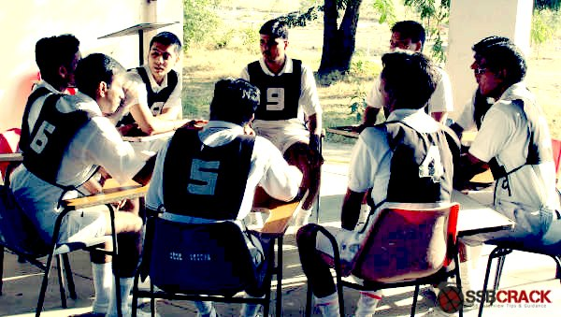
Introduction
Firstly, when you initiate a discussion, that not only shows your confidence but you also your ability to lead the group in the right direction. But it’s important that you give logical points while speaking first. The phrases you could use include:
- “With due respect, I would like to put forward the point that…”
- “Good morning ladies and gentleman, I would like to begin/start by saying that….”
- “I would like to begin by stating my view of the matter…”
Agreeing
Most of all, throughout the group discussion, it is necessary to keep in mind that the objective of this task is cooperation and a practical conclusion. It is essential that you make your point while respecting other’s views and opinions. Some phrases are:
- “I totally agree with….”
- “As a matter of fact, X is right by saying that…”
- “I think you are absolutely right”
- “I have to side with X on this one”
- “There can be no doubt that…”
Disagreeing
While agreeing is a positive deed, disagreeing, if not done appropriately could sound almost rude and impolite. The following phrases will help you to disagree politely.
- “With due respect, I believe it would be wrong to…”
- “With due respect, I would only partly agree to that…”
- “I feel it wouldn’t be right to….”
- “Though I agree with…. it seems to me that…”
Suggesting your opinion
Firstly, your points must be such that they are convincing and assertive. Moreover, putting your idea into comprehensible sentences is necessary. Therefore the following phrases will help you through the same.
- “My honest opinion would be that…”
- “The way I see it….”
- “The point I would like to make is that…”
- “I would like to say that..”
- “I am of the opinion that…”
Asking for clarification
While a point is made, it is necessary that the entire group gets the gist of it. In case you don’t understand a view of someone, it is advisable to ask them to repeat it. Moreover, it will show your interest and eagerness to participate in the discussion. Some phrases are:
- “I’m sorry but could you please make it more clear…”
- “If you don’t mind, could you please repeat that again…”
Interrupting Politely
Sometimes, there occur situations where you have to interrupt because you want to add a valuable information to the already made point. Therefore, here are some phrases to use in such situations.
- “Sorry to interrupt, but …”
- “I would like to add here that…”
- “Is it okay if I add something here….”
- “If I may interrupt, I would like to add that..”
Other Useful Phrases
In addition, to the already mentioned phrases, here are a few more to be used in specific situations.
- Relating to ground reality: “In today’s world..”
- Stating popular facts: “As a matter of fact…”
- Thanking someone, before making your point: “Thank you for asking my opinion…”
- Giving a chance to someone: “What do you think about this, X?”
- Quoting someone popular: “As X had once said….

